**Lesson15 Apply Docker on Ubuntu VM**

**Steps: -**

**1-on Azure Portal > create ubuntu server**

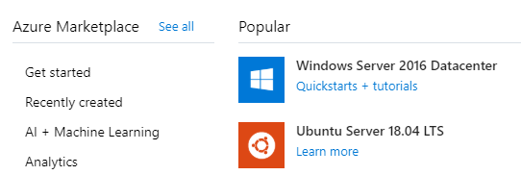

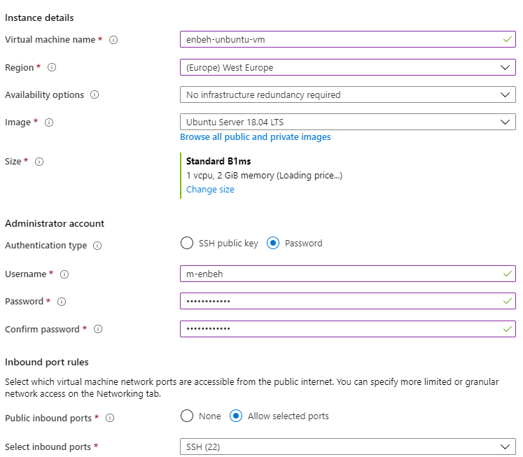

**2-on azure portal 🡪 we take the public IP address and use PUTTY to connect to the VM**



**3-we allow port 80 to any**

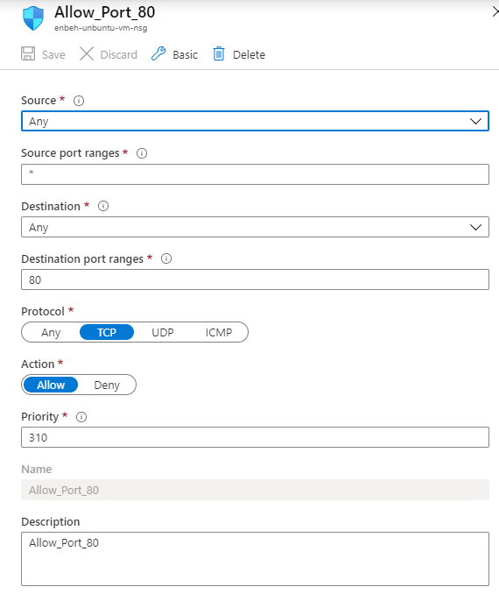

**3-On Putty we connect to VM ubuntu with specify username and password**

**Username m-enbeh**

**Password Mohammed1993**

**sudo apt update //to update package index**

**sudo apt install apt-transport-https ca-certificates curl software-properties-common //to add ubunto offical key**

**curl -fsSL https://download.docker.com/linux/ubuntu/gpg | sudo apt-key add -**

**//to get docker key and applied**

**sudo add-apt-repository "deb [arch=amd64] https://download.docker.com/linux/ubuntu bionic stable" //to add docker repository**

**sudo apt update //to update package index**

**sudo apt install docker-ce //to install docker**

**sudo docker run --name mynginx1 -p 80:80 -d nginx //to run docker**

**//we will download and uppload the image called nginx**

**sudo docker pull nginx:1.17.0 //to install nginx image on docker hub**

**sudo docker images //to show all images of docker hub**

**sudo docker run --name sampleapp -p 80:80 -d nginx:1.17.0**

**//to run the contrainer called sampleapp inside the installed image nginx on port 80**

**sudo docker container ls //to get list of containers**

**4-copy and paste public IP address on new tab and you will see that the web server nginx is installed on container**

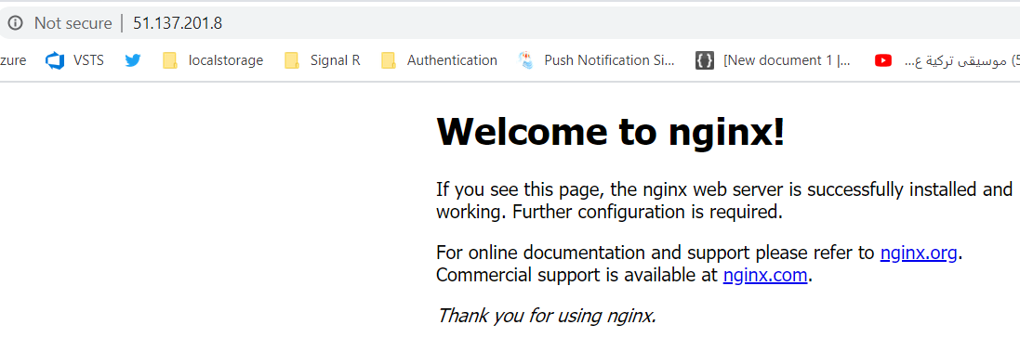

**How the operation is happening for Docker Image**

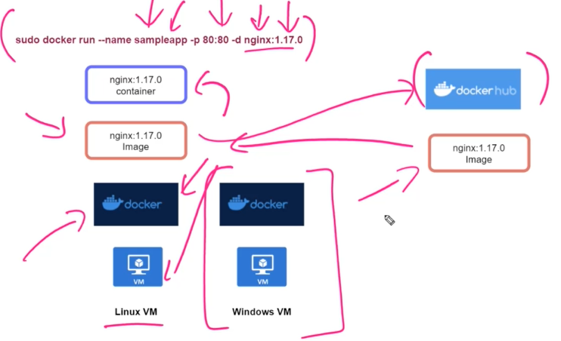

**1-on VM like windows / Linux , we install docker**

**sudo apt install docker-ce //to install docker**

**2-then we will request for the docker image called nginx from docker hub that will get it and download image to the local VM**

**3-then execute running container with A azure image**

**sudo docker run --name sampleapp -p 80:80 -d nginx:1.17.0**